ASSIGNMENT 4
Linux architechture
Linux is an open-source operating system kernel that serves as the core of various Linux distributions (often called "distros"). The architecture of Linux can be understood from multiple perspectives, including its components, design principles, and system organization.
Architecture of Linux system:
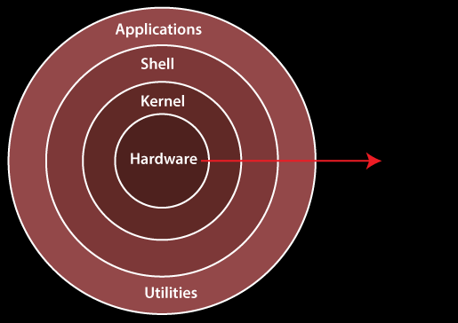
1. Kernel:- The kernel is one of the core section of an operating system. It is responsible for each of the major actions of the Linux OS. This operating system contains distinct types of modules and cooperates with underlying hardware directly. The kernel facilitates required abstraction for hiding details of low-level hardware or application programs to the system. There are some of the important kernel types which are mentioned below:
- Monolithic Kernel
- Micro kernels
- Exo kernels
- Hybrid kernels
2. System Libraries:- System libraries in Linux are collections of precompiled code and functions that provide essential services and interfaces for applications and user-level processes. These libraries abstract and encapsulate low-level interactions with the Linux operating system kernel and hardware, making it easier for developers to create software that runs on Linux. System libraries serve as a bridge between the kernel and user-level applications, offering a standardized way to access various system resources and perform common tasks.

3. System Utility Programs:- It is responsible for doing specialized level and individual activities.It is a collection of software tools and applications that serve various administrative and maintenance purposes within the Linux operating system. These utilities are used to manage and configure the system, monitor performance, troubleshoot issues, and perform tasks related to system administration. They are typically run from the command line, but some may have graphical user interfaces (GUIs) as well

4. Hardware layer:- In the context of Linux architecture, the hardware layer refers to the lowest level of the system stack, where the Linux kernel interacts directly with the physical hardware of the computer. This layer is responsible for managing and controlling hardware resources, such as the CPU, memory, storage devices, input/output (I/O) devices, and network interfaces

5. Shell:- It is an interface among the kernel and user. It can afford the services of kernel. It can take commands through the user and runs the functions of the kernel. The shell is available in distinct types of OSes. These operating systems are categorized into two different types, which are the graphical shells and command-line shells.

The graphical line shells facilitate the graphical user interface, while the command line shells facilitate the command line interface. Thus, both of these shells implement operations. However, the graphical user interface shells work slower as compared to the command-line interface shells.

There are a few types of these shells which are categorized as follows:

- Korn shell
- Bourne shell
- C shell
- POSIX shell

